Expiry Item List

This report provides the list of all the items that are to be expired as of now or all the items as of now with expiry date.
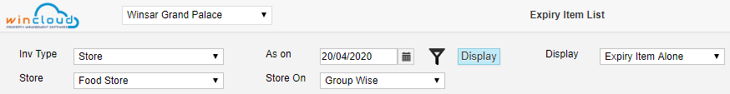
Funnel Filter is provided to search specific product group or product itself.
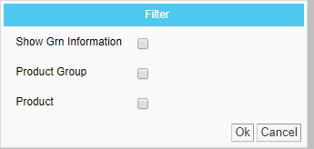

This option is provided to filter only expired item or all the items.
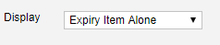
And Sort by or group by in Store on option.
